Contents

Intro to Human Computer Interaction 3

Ideal Interaction 3

Multi-Disciplinary Subject 3

Physchology and Cognitive Science 3

Ergonomics 3

Sociology 3

Business 3

Human Input-Output Channel 4

Input 4

Output 4

Human Memory 4

Sensory Memory 4

Short-term Memory 5

Long-term Memory 5

Thinking Reasoning and Problem Solving 6

Deductive Reasoning: 6

Inductive Reasoning: 7

Abductive Reasoning: 7

Norman’s Model Of Interaction 8

Execution 8

Evaluation 8

Example of Norman’s Model 8

Gulf of Execution and Evaluation 9

Gulf of Execution 9

Example: Online purchase 9

Gulf of Evaluation 9

Example: Copying a large number of files 9

Slips and Errors 9

Slips 9

Errors 9

Ergonomics 9

Arrangement of controls and display 10

The physical Enviroment of Interaction 10

Heath Issues 10

Use of Colour 10

Industrial and Glass Interfaces 10

Industrial Interface 10

Glass Interface 11

Example 11

Direct and Indirect Manipulation 11

Direct Manipulation 11

Indirect Manipulation 11

Example: Industrial Work 11

Common Interaction Styles 11

Command Line Interface 11

Menus 12

Example: Payment Method (Switch Case) 12

Natural Language 12

Question/Answer and Query Dialogue 12

Form Fills 12

Point and Click 12

3D Interface 12

Chapter 7 – Design Rules 12

Principles of Usability 12

Standards and Guidelines 13

Design Patterns 13

Types of Design Rules 13

Principles 13

Standards 13

Guidelines 13

Principles to Support Usability 13

LearnabIlity 13

Flexibility 14

Robustness 15

Shneiderman’s 8 Golden Rules Of Interface Design 15

# Intro to Human Computer Interaction

Human-Computer Interaction is a multidisciplinary field of study focusing on design of computer technology and, in particular, the interaction between humans (the users) and computers.

## Ideal Interaction

Human gives an input, for suppose, human want’s to perform a particular task, there are limitations to how and when it needs to be done, considering all these restrictions if the computer produces the desired output, then we can say that the interaction was an ideal interaction.

**Example:** Android and Windows, these are available in every house. Since these systems are user-friendly and easy to use.

# Multi-Disciplinary Subject

## Physchology and Cognitive Science

In these respective fields we are trying to study human mind, how does the brain work, its functionality and behavior. How does the mind work, when it is given a problem, how does it approach to a solution?

And then making changes in the product after collecting all the information about a human mind.

## Ergonomics

The study of people's efficiency in their working environment.

**Example:** A perfect human posture while using the computer (Height of the computer, poster of the person using it)

## Sociology

The study of the development, structure, and functioning of human society and the study of social problems.

**Example:** How does one human behave to another.

## Business

Consider you have full the requirements for an ideal product, but how would be it of any use if you cannot sell it to the people, or market your product.

Many more fields are involved in HCI, like Graphics design, Technical writing.

# Human Input-Output Channel

Human Output = Computer Input

Computer Output = Human Input

### Input

1. **Sight**

We perceive the environment through our sight.

Behavior: Our eyes get affected by the brightness/light.

HCI: Auto brightness in products.

Without HCI there would only have been 2 extreme points, 0% and 100% = Eyes fucked.

There shouldn’t be any font or visual ambiguity for the human. (B 13)

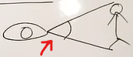

Visual Angle (It varies due to size and distance of objects)

1. **Hearing**

Input: Increase the volume.

Behavior: High volume can damage our hearing.

HCI: Window pop-up after 75% volume (High volume can damage your ears)

1. **Touch**

HCI: When pressing a key on keyboard, the key being pressed is felt, same case with mouse, touch screen, etc.

### Output

1. Limbs
2. Fingers
3. Head/Body position
4. Voice

# Human Memory

## Sensory Memory

Sensory = Human Senses.

Iconic Memory: Visual Stimuli

Echoic Memory: Hearing Stimuli

Haptic Memory: Touch Stimuli

**Sensory Memory -------- Attention ----🡪 Short – term Memory**

**Attention:** A lot of senses are present in sensory memory at the same time, but you have to filter out only the important ones with **Attention**.

**Example:** You are blindfolded and are tasked to guess the animal by hearing It’s sound, at this time your main focus will be your Hearing Stimuli.

## Short-term Memory

After being filtered out the important senses (Attention) is passed to Short-Term Memory.

Short term memory 🡪 Temporary stored data.

**Example:** English Comprehension, “Read the passage and answer the questions below”.

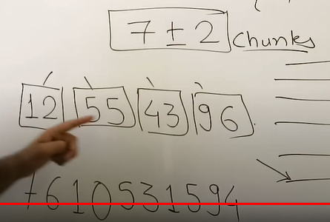

## Long-term Memory

* Long term memory is our main resource, it’s our main storage, long-term memory defines our individuality. Cause on the basis of this memory you interact with your environment.
* Long term memory takes longer to get accessed as compared to short term memory.

1. **Information Store:**

Repeated exposure to a stimuli store that information in our long-term memory.

1. **Loss of information: (Retroactive interference)**

Sometimes new information completely masks our previous information, making us forget it completely.

1. **Retrieval of information:**

Recalling something from our memory.

*Long term memory is of two types:*

1. **Episodic**

All actions, events and experience of our lives are remembered in a sequence.

1. **Semantic**

All the skills, and knowledge we have acquired in our lives is stored in our semantic memory.

**Semantic Structures:**

1. **Semantic Network:**

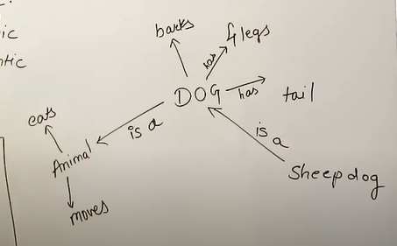

1. **Frame based structure:**

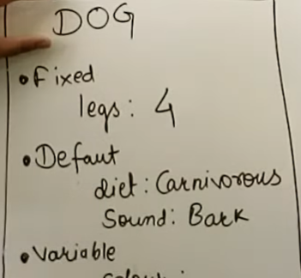

# Thinking Reasoning and Problem Solving

## Deductive Reasoning:

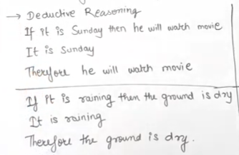

## Inductive Reasoning:

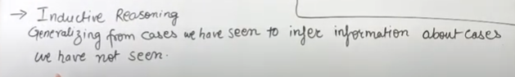

**For Example:** I saw an elephant with a trunk, I generalized that every animal in the world will have a trunk.

We must prove or disprove our statement.

An example of inductive logic is, "The coin I pulled from the bag is a penny. That coin is a penny. A third coin from the bag is a penny. Therefore, all the coins in the bag are pennies."

## Abductive Reasoning:

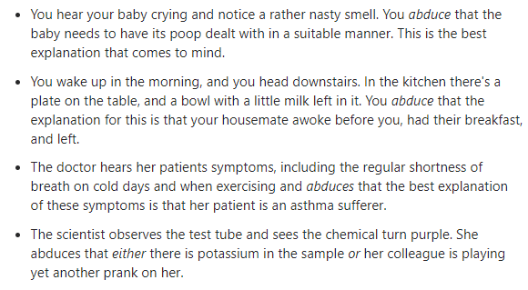

# Norman’s Model Of Interaction

1. Establishing the goal.
2. Forming the intention.
3. Specifying the action sequence.
4. Executing the action.
5. Perceiving the system state.
6. Interpreting the system state.
7. Evaluating the system state.

## Execution

System performing the actions assigned by the user, to achieve a specific task.

## Evaluation

User evaluate the system generated output by comparing it his desired output.

### Example of Norman’s Model

1. Need to light up a dark room.
2. Turn on light bulb switch.
3. Stand up 🡪 Go to the Switch 🡪 Turn on the switch.
4. Execute step (3).
5. Observe the system (Did the lights turn on or not?).
6. If the goal was not achieved, you interpret the system. (Is the bulb expired?).
7. If the goal was achieved, you compare the output with your desired output.

# Gulf of Execution and Evaluation

## Gulf of Execution

Disparity between the user’s perception of the required system interactions to achieve desired goal, and the actual system interaction required to achieve goal.

### Example: Online purchase

**Large gulf of execution:** Add item to cart, select checkout, enter shipping address, choose shipping options, enter billing address, enter payment details, accept/decline extra offers, review order, confirm order.

**Small gulf of execution:** Amazon’s 1-Click Ordering.

## Gulf of Evaluation

Disparity between the user’s perception (or discovery) of the system state, and the actual system state.

### Example: Copying a large number of files

**Large gulf of evaluation:** Hourglass, spinning pinwheel, no details.

**Small gulf of evaluation:** Progress bar with listing of current file being copied, and estimated completion time.

# Slips and Errors

## Slips

Right intention but failed to do it right.

Causes: Poor physical skills 🡪 Trying to catch a ball but slipped. Inattention.

## Errors

Wrong intention.

Cause: Incorrect understanding.

# Ergonomics

Ergonomics means “Fitting the job for the worker”.

## Arrangement of controls and display

Controls on screen should be logically grouped. (Time efficient)

Example:

Google apps are arranged and stored in a google folder. (Easy Access)

Notification should be really clear on screen: Pop-up on middle of the screen instead of some corner.

## The physical Enviroment of Interaction

1. Body posture
2. Environment
3. Eye-Sight Level
4. Workspace Temperature
5. Lighting
6. Noise
7. Timing

## Heath Issues

If physical environment of interaction in not well defined, health issues will arise.

For Example: Bad Eye-Sight level, and body posture might lead to eye problems, back pain, and neck strains.

Noise can lead to ear problems and work distractions.

## Use of Colour

COLOUR MATTER!

Dark-mode, Light-mode.

Red: Warning, Indication.

Yellow: Attention.

Green: Secure.

Example: Phone Battery %.

# Industrial and Glass Interfaces

## Industrial Interface

1. Dials and Knobs.

## Glass Interface

1. Screens and Keypads.
2. Cheaper, More flexible, Multiple representation, Precise values.

* Complex interfaces sometimes.

Sometimes both are needed.

### Example

Cockpit of an Aircraft.

# Direct and Indirect Manipulation

## Direct Manipulation

* User ↔ System Interaction.
* Direct and Rapid Feedback.

## Indirect Manipulation

* User 🡪 Interface 🡪 Real World.
* Slow Feedback, and Delays.

### Example: Industrial Work

* You wanted to pack everything in a square box, yet you selected a circular box, and now everything is packed in circular.

# Common Interaction Styles

1. Command Line Interface
2. Menus
3. Natural Language
4. Question/Answer and Query Dialogue
5. Form-Fills and Spreadsheets
6. Point and click
7. 3D interfaces

## Command Line Interface

* First primitive interaction style.
* Command line is really easy-to-understand for system, it takes commands directly without any ambiguity. But user has to learn how to use CMD.
* User needs to be a command line commands expert for an ideal interaction.
* Poor User-System interaction.

## Menus

### Example: Payment Method (Switch Case)

* Payment Menu:

1. Cash
2. Card
3. Net Payment

## Natural Language

* Communicating with the system through our daily-spoken language.
* Easy for Human, Complex for computers.
* High chance of Ambiguity.

## Question/Answer and Query Dialogue

* In this case a pattern of Question and Answers is followed.
* Example: Chatbot on Facebook and Instagram.
* Restrictions: Answers are domain related, not universal.

## Form Fills

* Simple real-world form-fills implemented in virtual world.
* User friendly, and easy to use.
* Not much knowledge needed to use.
* Mostly used on data entry applications.

## Point and Click

* Most commonly used interface.
* Example: Maps, Hyperlinks.
* Touch Screen is also a primitive implementation of Point and Click interface.

## 3D Interface

* Virtual Reality based applications.
* 3D Animated webpages.

# Chapter 7 – Design Rules

### Principles of Usability

* General Understanding.

### Standards and Guidelines

* Direction for design.
* Standard is of Product, and Quality is measured by client.
* If the product fulfills all the requirements, then the product is quality product.
* **Standard:** A fan button should be of standard size; it doesn’t have to be of a size of a hand.

### Design Patterns

* Capture and reuse design knowledge.

## Types of Design Rules

### Principles

* E.g. System should be easy to interact.
* Abstract design rules (All the rules discussed above should be implemented.)
* Low authority: Access to the database should be given to as minimum people as possible.
* High Generality: General standard of the application domain must be followed while developing the product.

Example: Test Cases -> X ID must be present in database, instead of 19k1048.

### Standards

* Specific design rules.
* High Authority (ISO)
* Limited Application

### Guidelines

* E.g. Use color to highlight links.
* Can guide on how to achieve a principle.
* Lower Authority
* More general application.

## Principles to Support Usability

### LearnabIlity

* The ease with which new user can begin effective interaction and achieve maximal performance.
* **Predictability:** support for the user to determine the effect of future action based on past interaction history (can I ‘tell’ what will happen based on what I have gone through in past?)

**Synthesizability:** support for the user to assess the effect of past operations on the current state (can I ‘tell’ why I am here based on what I have gone through in the past?)

**Familiarity:** the extent to which a user's knowledge and experience in other real world or computer-based domains can be applied when interacting with a new system.

**EG:** MS Word -> Typewriter.

**Generalizability:** support for the user to extend knowledge of specific interaction within and across applications to other similar situations.

**EG:** Cut, copy, paste. Circle -> Ellipse, Square -> Rectangle.

**Consistency:** likeness in input-output behavior arising from similar situations or similar task objectives.

When keyboards for typewriters were first made, the designers laid out the keys in alphabetical order. Then it was discovered that such an arrangement of keys was both inefficient from the machine’s perspective (adjacent typewriter keys pressed in succession caused jams in the mechanism, so the likelihood of this occurrence had to be designed out) and tiring for the typist (a touch-typist would not have equal stress distributed over all fingers) The resulting QWERTY and DVORAK keyboards have since been adopted to combat the problems of the ‘consistent’ keyboard layout.

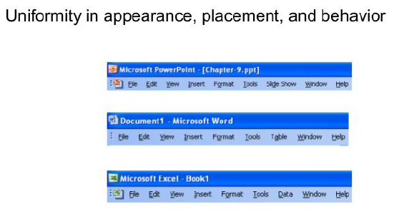

### Flexibility

* The multiplicity of ways in which user and system exchange information.

**Dialogue initiative:** user freedom from artificial constraints on the input dialog imposed by the system; user vs system - who has the initiative in the dialog?

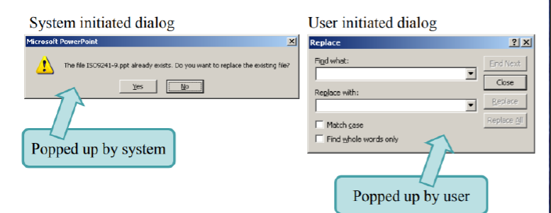

**Multithreading:** The ability of the system to support user interaction for more than one task at a time.

E.g. Tabs, Windows.

**Task Migratability:** The ability to transfer control for execution of tasks between the system and the user (consider e.g., spell-checking task).

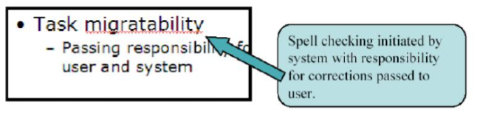

**Substitutivity:** The extent to which an application allows equivalent input and output values to be substituted for each other (values in input e.g. fractions/decimals, values in output e.g. both digital and analog, output/input e.g. output can be reused as input).

**Customizability:** the ability of the user or the system to modify the user interface. (adaptability vs adaptivity)? - initiated modification.

### Robustness

* The level of support provided to the user in determining successful achievement and assessment of goals.
* **Observability:** The extent to which the user can evaluate the internal state of the system from the representation on the user interface.
  + **Mail, Loading, Downloading.**
* **Recoverability:** The extent to which the user can reach the intended goal after recognizing an error in the previous interaction.
* **Responsiveness:** A measure of the rate of communication between the user and the system.
* **Task conformance:** The extent to which the system services support all the tasks the user would wish to perform and in the way the user would wish to perform.

## Shneiderman’s 8 Golden Rules Of Interface Design

1. Strive for consistency

Example: Mac OS menu bar 🡪 Graphical Elements.

Else user will have to spend time learning new interface, User effort++ = Bad interface.

1. Enable frequent users to use shortcuts

**Example:** Keyboard Accelerators 🡪 Keyboard shortcuts.

1. Offer informative feedback

Every action performed should have a respective feedback, and in human understandable form.

Instant or short time response.

1. Design dialogs to yield closure

Don’t keep the user guessing.

Gulf of evaluation concept.

1. Offer error prevention and simple error handling

Example: Online form filling, when a mandatory field is not filled, redirect the user to that field.

1. Permit easy reversal of actions.

Undo for every step.

Instead of starting for the starting point.

1. Support internal locus of control.

Make the user feel as if the whole system is in his control.

1. Reduce short - term memory long term memory load.

Recognition rather than recall.

No more than 5-6 details on a single screen.

## Norman’s 7 Princle

1. Use both knowledge in the world and knowledge in the head.
2. Simplify the structure of tasks.

Decompose the big task into smaller tasks.

1. Make things visible: bridge the gulfs of Execution and Evaluation.
2. Get the mappings right.

E.g. Buttons and Lights mapping.

Icons on Apps.

1. Exploit the power of constraints, both natural and artificial.
2. Design for error.

E.g. Undo Feature.

1. When all else fails, standardize.

# Chapter 9 – Evaluation Techniques